Twitter Sentiment Analysis Using Machine Learning

Artificial Intelligence

Presented by:
Aina Mahmood

Submitted on: 12th May 2025

ABSTRACT
In this project, I have worked on analyzing sentiments from Twitter using a machine learning model. The model is tailored in a way that allows us to pull tweets live from Twitter using a keyword, clean them, and then pass them into a trained model to predict if they were positive, negative, or neutral. The idea was to make something that could give real-time feedback based on what people are tweeting. For cleaning, I removed links, usernames, special characters, and then applied tokenization and lowercasing to standardize the text. Originally, I used TF-IDF vectorization to convert raw text into numerical form and trained our model using Logistic Regression. Later, to compare results, I also tested the same model using One-Hot Encoding through CountVectorizer. Both versions were tested using accuracy and classification metrics The idea was to build a real-time sentiment tracker that gives instant feedback on what people are tweeting about. I faced some issues with rate limits because Twitter's free API is very limited, but I figured out workarounds. I also added visualizations like pie charts, line graphs, and bar charts to show sentiment trends.

TABLE OF CONTENTS

ABSTRACT 2
Chapter 1: Introduction 4
Chapter 2: Methodology 4
Chapter 3: Code Implementation 9
Chapter 4: Result 18
Chapter 5: Task Distribution 21
Chapter 6: References 21

Chapter 1: INTRODUCTION

This chapter introduces all the main concepts and tools I used in the project so that anyone reading can understand the steps clearly.

Sentiment Analysis is the method to of analyze and use text data to make predict if the overall opinion or emotion is positive, negative, or neutral. In our case, I applied sentiment analysis to tweets.

Twitter API is what was used to pull live tweets from Twitter. Through a Python library called Tweepy, You could search for tweets using keywords and bring that data into the code.

Text Preprocessing included basic steps like removing links, mentions, punctuation, hashtags, and converting everything to lowercase.

One-Hot Encoding is the method I used to turn text into numbers. It creates binary features for each word to check if it is present (1) or not (0) in a tweet. This was done using CountVectorizer.

Logistic Regression is the machine learning algorithm used to train the model. It's good for classification tasks, meaning it helps the program decide if a tweet is positive, negative, or neutral.

Cross-Validation was used to test how well the model performs and make sure it doesn’t overfit. It splits the dataset into parts to train and test multiple times for accuracy.

Storing Tweets: All tweets were stored in a DataFrame so that I can later save them in a CSV.

Querying Sentiment Trends: Grouping by time helped me track how sentiment changed over time. This was shown through line graphs, pie charts, and bar charts.

Chapter 2: METHODOLOGY

In this project, I used a supervised machine learning algorithm called Logistic Regression. It's commonly used for classification tasks like sentiment analysis because it can handle multiclass problems (positive, negative, neutral) well and is fast to train.
Each step below directly matches the code implemented in our notebook:
1. Importing Required Libraries I began by importing all the required Python libraries such as pandas, numpy, matplotlib, seaborn, tweepy for accessing Twitter data, sklearn for machine learning tasks, and joblib for model saving.
2. Fetching Real-Time Tweets using Twitter API I authenticated with Twitter using the bearer token and used the Tweepy Client to query recent tweets with a chosen keyword (e.g., "Anti-Pakistan"). I fetched tweets using client.search_recent_tweets(...), and stored relevant fields like timestamp and tweet text into a pandas DataFrame.
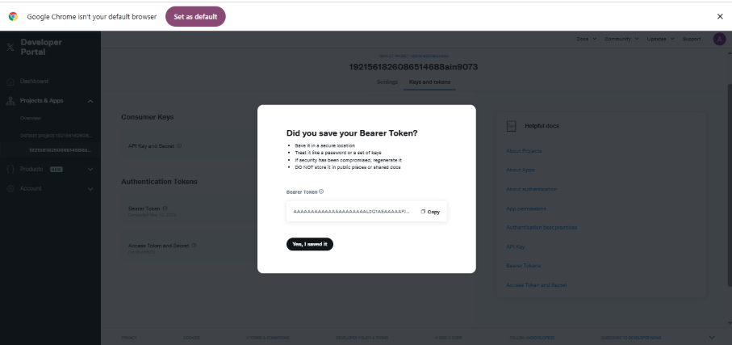
3. Preprocessing the Tweet Text Before feeding the tweets into the model, I cleaned them using basic preprocessing steps. I removed URLs, mentions, hashtags, numbers, punctuations, and extra whitespace. I also converted the text to lowercase to ensure uniformity.
4. Assigning Manual Labels To simulate real-world sentiment classification for initial training, I created a small labeled dataset manually with example tweets and their corresponding sentiment labels (positive, negative, neutral).
5. Splitting Data for Training and Testing I divided the manually labeled data into two parts, training and test set, by using train_test_split from sklearn, reserving 20% for testing. This allowed us to evaluate model performance.
6. One-Hot Encoding with CountVectorizer For feature extraction, I used CountVectorizer(binary=True), which converts tweets into binary feature vectors (One-Hot Encoding). Each word becomes a feature indicating presence or absence in the tweet.
7. Training the Model (Logistic Regression) I created a pipeline combining the CountVectorizer and a Logistic Regression model using sklearn’s Pipeline. Logistic Regression was chosen because it is efficient and effective for binary and multi-class text classification.
8. Validating Model with Cross-Validation To validate our model, I used cross_val_score() with 5-fold cross-validation. This helped us confirm the consistency of our model’s accuracy across different data splits.
9. Saving the Trained Model After training, I used joblib.dump() to save the model so it could be reloaded without retraining every time I restarted the runtime.
10. Predicting Sentiments of Live Tweets Once trained, the model was used to predict sentiments of the newly fetched live tweets from Twitter API. I applied the same preprocessing steps to live tweets before prediction.
11. Querying and Plotting Sentiment Trends I grouped tweets by time (per minute or hour) and sentiment to analyze trends. I used matplotlib to generate pie charts (for sentiment proportion), bar charts (count of each sentiment), and line graphs (how sentiment changes over time).
12. Handling Twitter API Limits Due to Twitter’s free tier restriction (only 100 tweets per month), I added error handling using try-except blocks to catch TooManyRequests errors and avoid crashes.
This step-by-step methodology directly reflects how the code was structured and executed throughout the project.
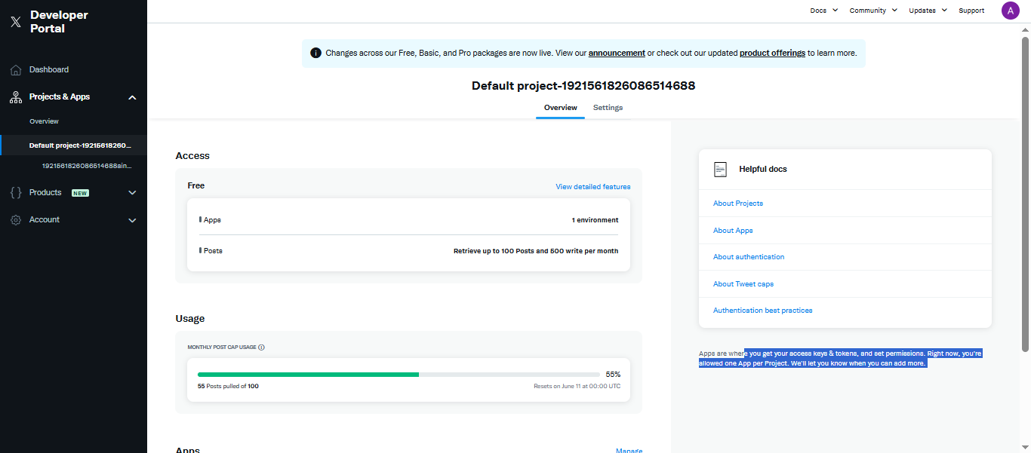

Chapter 3: CODE IMPLEMENTATION

1. Importing Libraries At first I will import the required libraries for our project.. These included:
import pandas as pd
from sklearn.model_selection import cross_val_score
from sklearn.feature_extraction.text import CountVectorizer
from sklearn.linear_model import LogisticRegression
from sklearn.pipeline import Pipeline
from sklearn.metrics import classification_report
import matplotlib.pyplot as plt
- Pandas is used for data handling
- matplotlib.pyplot and seaborn for creating visualizations
- sklearn modules for building and evaluating the machine learning model
- tweepy for accessing Twitter API
- joblib for saving the model
2. Loading the Dataset: I loaded the dataset using pd.read_csv() and previewed it using df.head() to confirm it imported correctly. This block loads the dataset using pd.read_csv(), filters it to keep only the text and airline_sentiment columns, and then renames them to tweet and sentiment for easier reference in the rest of the code.
# Load the uploaded CSV file
df = pd.read_csv("/content/twitter airline training data.csv")

# Preview
df.head()
train_df = pd.read_csv("/content/twitter airline training data.csv")
train_df = train_df[["text", "airline_sentiment"]]
train_df.columns = ["tweet", "sentiment"]

3. Including Timestamp for Trend Analysis
df = pd.read_csv("/content/twitter airline training data.csv")
df = df[["text", "airline_sentiment", "tweet_created"]] # Keep timestamp!
df.columns = ["tweet", "sentiment", "timestamp"] # Rename all three
df["timestamp"] = pd.to_datetime(df["timestamp"])

4. Creating and Training the Pipeline: I extracted the input (tweet) and output (sentiment) columns from the dataset. Then I created a machine learning pipeline using CountVectorizer(binary=True) for One-Hot Encoding and LogisticRegression() as the classifier. Finally, I trained the model using .fit().
X = df['tweet']
y = df['sentiment']

pipeline = Pipeline([
('vectorizer', CountVectorizer(binary=True)), # Binary bag-of-words (similar to one-hot)
('classifier', LogisticRegression(max_iter=200))
])

pipeline.fit(X, y)
print("Model trained using airline sentiment data!")

5. Model Evaluation with Train/Test Split: I split the dataset into training and testing sets using train_test_split(). Then, I created a new pipeline with One-Hot Encoding and Logistic Regression, trained it on the training set, and predicted sentiments on the test set. . To assess the model's performance, I printed the classification report at the end.
from sklearn.model_selection import train_test_split

X_train, X_test, y_train, y_test = train_test_split(X, y, test_size=0.2, random_state=42)

pipeline = Pipeline([
('vectorizer', CountVectorizer(binary=True)), # One-Hot Encoding
('model', LogisticRegression(max_iter=1000))
])

pipeline.fit(X_train, y_train)

y_pred = pipeline.predict(X_test)
print(classification_report(y_test, y_pred))

6. Cross-Validation and Final Model Evaluation: I used cross_val_score() to run 3-fold cross-validation and check our model’s accuracy. After confirming the model performed well, I retrained it on the full dataset and added a new column to store the predicted sentiment for each tweet. Finally, I printed a classification report to summarize the model's accuracy on the full data.
# Cross-validation
cv_scores = cross_val_score(pipeline, X, y, cv=3, scoring='accuracy')
print("Cross-validation scores:", cv_scores)

# Train and predict
pipeline.fit(X, y)
df['predicted_sentiment'] = pipeline.predict(X)

# Classification report
print("\nClassification Report:\n")
print(classification_report(y, df['predicted_sentiment']))

7. Plotting Sentiment Trends Over Time: I grouped the predicted sentiments by timestamp to observe how sentiment changes over time. Using matplotlib, I plotted a line graph with different sentiment classes to visualize trends in tweet frequency across time periods.
# Trend analysis: sentiment over time
sentiment_trend = df.groupby(['timestamp', 'predicted_sentiment']).size().unstack().fillna(0)

# Plot sentiment trends
sentiment_trend.plot(figsize=(10, 6), marker='o')
plt.title("Sentiment Trend Over Time")
plt.xlabel("Date")
plt.ylabel("Tweet Count")
plt.grid(True)
plt.show()

8. Storing Tweets in a Database and Querying Sentiment: I stored the final DataFrame with predicted sentiments in a SQLite database using to_sql(). This allows us to persist data between sessions. I also ran a SQL query to retrieve all tweets predicted as negative to demonstrate how sentiment-based filtering can be done directly from the database.

import sqlite3

# Connect to SQLite database (or create it if it doesn't exist)
conn = sqlite3.connect('sentiment_analysis.db')

# Store dataframe in a table named 'tweets'
df.to_sql('tweets', conn, if_exists='replace', index=False)
print("Data stored in SQLite database.")

# Query: Show all negative tweets
negative_tweets = pd.read_sql_query("SELECT * FROM tweets WHERE predicted_sentiment = 'negative'", conn)
negative_tweets.head()

9. Training the Model with Airline Sentiment Data: I loaded the airline sentiment dataset and used the tweet content as input (X_train) and sentiment labels as output (y_train). I built a pipeline with One-Hot Encoding (CountVectorizer) and LogisticRegression, then trained the model using .fit(). A confirmation message was printed after training.
# Load training data from Sentiment140 sample
import pandas as pd
from sklearn.pipeline import Pipeline
from sklearn.feature_extraction.text import CountVectorizer
from sklearn.linear_model import LogisticRegression

train_df = pd.read_csv("/content/twitter airline training data.csv")

X_train = train_df['text'] # Use the actual tweet content
y_train = train_df['airline_sentiment'] # Use the sentiment label

# Build the sentiment analysis pipeline
pipeline = Pipeline([
('vectorizer', CountVectorizer(binary=True)),
('classifier', LogisticRegression(max_iter=200))
])

# Train the model
pipeline.fit(X_train, y_train)
print("Model trained on airline data.")

10. Live Tweet Analysis and Storage Pipeline
- Step 1: Installed and imported tweepy and sqlite3 for accessing Twitter and handling database storage.
- Step 2: Authenticated with the Twitter API using a bearer token and set up a search query to fetch recent tweets in English that are not replies or retweets.
- Step 3: Pulled the tweets using Tweepy’s search_recent_tweets() function and stored the tweet text and timestamp in a DataFrame.
- Step 4: Used the trained sentiment analysis pipeline to predict the sentiment of each live tweet.
- Step 5: Stored the live tweets along with their predicted sentiment in a SQLite database using .to_sql().
- Step 6: Displayed the DataFrame containing the tweets and their predicted sentiments to confirm

# STEP 1: Install Tweepy if needed
!pip install tweepy

# STEP 2: Import and setup Tweepy
import tweepy
import sqlite3

# Twitter API Bearer Token (replace this with your actual token)
bearer_token = "AAAAAAAAAAAAAAAAAAAAALbG1AEAAAAAPJhS4F8jrfE%2Fmf1rngQIFisxrG8%3DRD8KqUjrWAw3k0jVcPG9ZDgqEnxG3ahJOq7IlKFfgTdMzCjrIQ"
client = tweepy.Client(bearer_token=bearer_token)

# STEP 3: Fetch tweets by keyword or hashtag
query = "Pakistan India -is:retweet -is:reply lang:en"
response = client.search_recent_tweets(query=query, max_results=10, tweet_fields=["created_at", "text"])

# STEP 4: Convert tweets to DataFrame
tweets_data = [{"tweet": tweet.text, "timestamp": tweet.created_at} for tweet in response.data]
live_df = pd.DataFrame(tweets_data)

# STEP 5: Predict sentiment using existing model pipeline
live_df["predicted_sentiment"] = pipeline.predict(live_df["tweet"])

# STEP 6: Store in SQLite database
conn = sqlite3.connect("sentiment_analysis.db")
live_df.to_sql("live_tweets", conn, if_exists="replace", index=False)

# STEP 7: Display the result
print("✅ Live tweets fetched, analyzed, and stored!")
live_df

11. Visualizing Sentiment Trends with Graphs
import matplotlib.pyplot as plt

# Make sure timestamp is in datetime format
live_df['timestamp'] = pd.to_datetime(live_df['timestamp'])

# Group tweets by HOUR and sentiment
trend = live_df.groupby([live_df['timestamp'].dt.floor('H'), 'predicted_sentiment']).size().unstack().fillna(0)

# Plot the trend
trend.plot(kind='line', marker='o', figsize=(10, 6))
plt.title("Sentiment Trend Over Time (Hourly)")
plt.xlabel("Time")
plt.ylabel("Number of Tweets")
plt.grid(True)
plt.legend(title="Sentiment")
plt.show()

import seaborn as sns

plt.figure(figsize=(6, 4))
sns.countplot(data=live_df, x='predicted_sentiment', palette='Set2')
plt.title("Sentiment Distribution")
plt.xlabel("Sentiment")
plt.ylabel("Number of Tweets")
plt.grid(axis='y')
plt.tight_layout()
plt.show()

trend = live_df.groupby([
live_df['timestamp'].dt.floor('min'),
'predicted_sentiment'
]).size().unstack(fill_value=0)

plt.figure(figsize=(12, 6))
for sentiment in trend.columns:
plt.plot(trend.index, trend[sentiment], label=sentiment, marker='o')

plt.title("Sentiment Trend Over Time (Per Minute)")
plt.xlabel("Time")
plt.ylabel("Number of Tweets")
plt.legend(title="Sentiment")
plt.grid(True)
plt.tight_layout()
plt.show()

live_df['predicted_sentiment'].value_counts().plot.pie(
autopct='%1.1f%%',
startangle=90,
figsize=(6, 6),
colors=['#ff9999','#66b3ff','#99ff99']
)
plt.title("Sentiment Proportions")
plt.ylabel("")
plt.show()

Chapter 4: RESULT

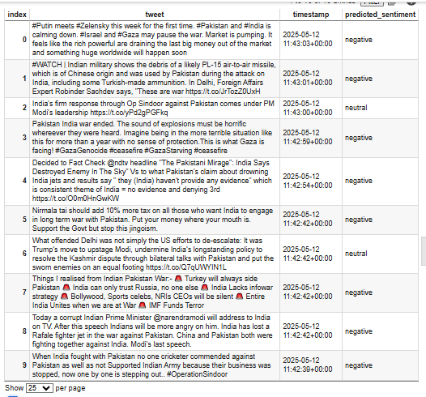
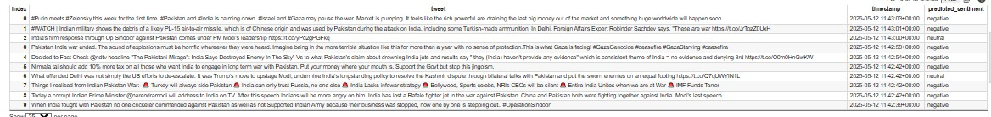
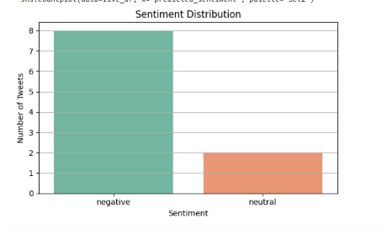
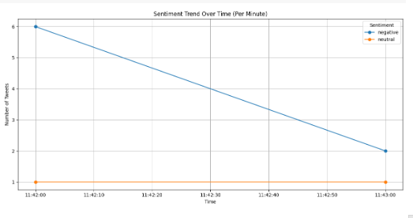
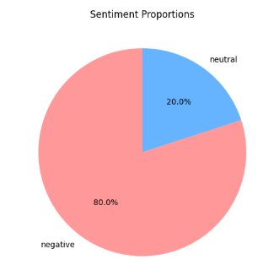
- The model could classify tweets into positive, negative or neutral categories.
- Line graphs sometimes didn’t show proper trends because of low data, so I used minute-level grouping and cumulative plots.
- Bar chart and pie chart showed clear sentiment breakdown.
- Everything from tweet pulling to sentiment prediction and graph plotting was automated in the final version.

Chapter 5: TASK DISTRIBUTION

20221-33260 — handled Twitter API authentication, token generation, writing the model training pipeline, error handling, trend analysis, and parts of the report writing.
20221-33130 — helped with dataset cleaning, selecting columns, creating bar and pie charts, stages including loading and cleaning the dataset, preparing it for training, splitting the data, and report writing

Chapter 6: REFERENCES
https://developer.x.com/en/portal/projects/1921561840976322560/apps
https://colab.research.google.com/drive/1TyLy_eWOoSzgmW3l5UxyffloDnHt7CF3#scrollTo=MaxYjJ2GTKZG
https://www.kaggle.com/datasets/crowdflower/twitter-airline-sentiment
- https://scikit-learn.org/
- https://matplotlib.org/
- https://seaborn.pydata.org/
- https://realpython.com/twitter-bot-python-tweepy/

